Dear Summer School Parents/Guardians,

In an effort to ensure that 100% of registered students are able to participate in credit recovery, we have an important update about your child’s learning model. **FBISD will allow students to choose the learning modality that works best for them this Summer (Face-to-Face or Online).** The online-only Edgenuity course will take the place of your student physically coming to a campus to take summer school credit recovery. This means that your child will not report to campus for school because all of their assignments and interactions will occur over the internet (on Edgenuity). Once you have chosen which modality you want, you will not be allowed to switch models during the Summer Session. However, if you would like to use a different model for Session II, than you did for Session I, that is acceptable. Please ensure that you have access to the internet and a device.

**How will I get information about the class?**

* Your summer school teacher will contact you on the first day of summer school.
* A link will be sent on June 9th for you to join using MS Teams on the first day of summer school at 7:30 a.m.
* You will find out more information about your course during that time.

**When will the class be?**

* Start Date for Session I: Monday, June 13th
* End Date for Session I: Thursday, June 30th
* Start Date for Session II: Monday, July 11th
* End Date for Session II: Thursday, July 28th
* Class Times: Monday through Thursday from 7:30 a.m. – 1:00 p.m. Students will be required to log in on a daily basis during this time frame and make steady progress towards their daily target of 10% work completion.
* Please note that this is a self-paced class, so it is possible for you to work ahead and complete the class early. Coursework includes instructional videos, lesson activities, quizzes, tests, and cumulative exam at the end of the course.

**Where will the class be?**

The expectation is that your child check in daily for attendance. All content for the class will be dispersed through Edgenuity. We have made changes to the way you log into Edgenuity, so I have attached a PDF help document to show you how to login. Edgenuity has many features. In addition, the daily check in with the teacher will help you stay on track and make sure you are completing the work in a timely manner so that you complete the course by the end date (June 30th). Each student has access to a progress report that updates in real time, so it’s easy to monitor completion rate in the course. There is a messaging feature in Edgenuity, so if you have a question you or your child can always message the teacher there.



 In order to receive credit, you must participate for synchronous help sessions Monday – Thursday, by joining a MS Teams link that will be given to you by your instructor.

**Technology Needs**

Students who need to check out a laptop for summer-school purposes, please visit/contact the depot locations listed below:

To better facilitate the checkout of student laptops with the summer school timelines, IT is moving all student laptop checkouts to a central checkout depot. Students will no longer be rushed to checkout a laptop from their campus library before the end of the school year without yet knowing their summer school status. Instead, IT will open a summer school laptop checkout depot at the Technology Education Center behind Dulles High School. As a reminder, laptops are only available for online programs. Students participating in face-to-face summer programs will use the technology provided in their classroom.

**Summer School Laptop Checkout Depot Location and Hours**

**Location**: Technical Education Center behind Dulles HS (540 Dulles Ave, Sugar Land, TX 77478)

**Dates**: 6/8, 6/9, 6/13, & 6/14

**Times**: 8am-12pm, 1pm-5pm daily

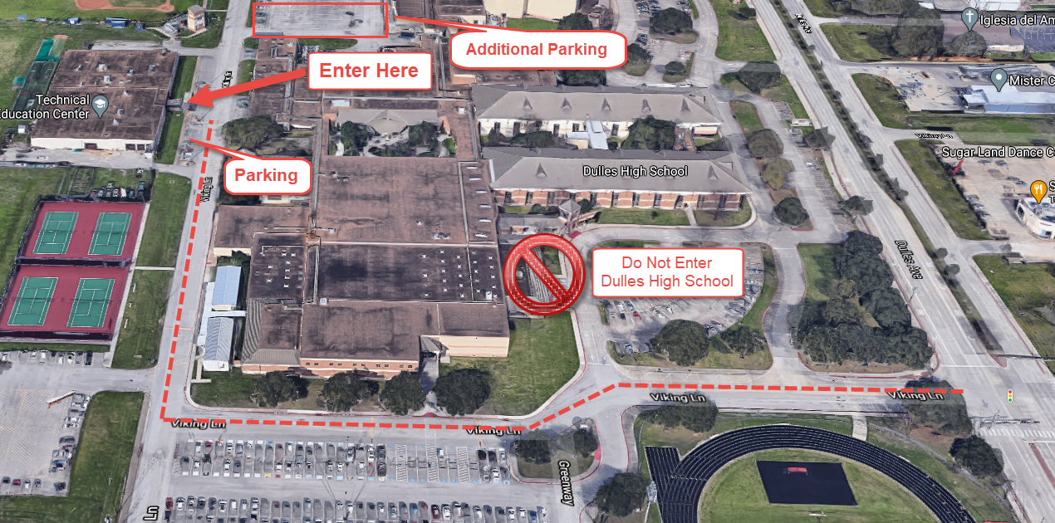

We look forward to working with your child this summer! Please see the additional attachments for Edgenuity log in instructions. Please expect another email from your teacher by June 9th. Thank you very much.

Sincerely,

Summer School Principal

Damien Bassett

Kempner High School